**10. ReactJS – HOL**

**Objectives**

* **Define JSX**

JSX stands for JavaScript XML.  
It lets you write HTML inside JavaScript.  
JSX makes code easier to write and read.

* **Explain about ECMA Script**

ECMAScript is the official name of JavaScript's standard.  
It defines how the language should work.  
  
For example:  
ES5 → Older version (used in older browsers)  
ES6 → Modern version (adds let, const, arrow functions, classes, etc.)

* **Explain React.createElement()**

A React Function that creates a React Element  
  
Example:  
*React.createElement(“hi”,null,”Hello”);* - Creates an h1 tag with “Hello” inside.

* **Explain how to create React nodes with JSX**

You can directly write HTML-like code using JSX inside a component.  
  
Example:  
*const element=<h1>Welcome</h1>*  
This creates a React node that shows Welcome! in the browser. Use {} for dynamic values inside JSX.

* **Define how to render JSX to DOM**  
  To render JSX on the browser, first import react-dom

*import ReactDOM from “react-dom”;*  
  
*ReactDOM.render(<h1>Hello</h1>,document.getElementById(“root”));*

* **Explain how to use JavaScript expressions in JSX**

Javascript expressions can be used in JSX

Example:

*const name= “vika”;*

*const element=<h1>Hello {name} </h1>;*

Output:

Hello vika

* **Explain how to use inline CSS in JSX**

In JSX, JavaScript object can be passed to the style attribute.

Example:

*const obj={color:”Red”,fontsize:20px};*

*<h1 style={obj}>Text</h1>*

(Or)

*<h1 style={{color:”Red”,fontsize:20px}}>Text</h1>*

**EXERCISE – 2:** Creation of an Office Space Rental App

Step 1: Open **VS Code**

Step 2: Create a New React App

**npx create-react-app officespacerentalapp**

Step 3: Navigate into the project folder

**cd officespacerentalapp**

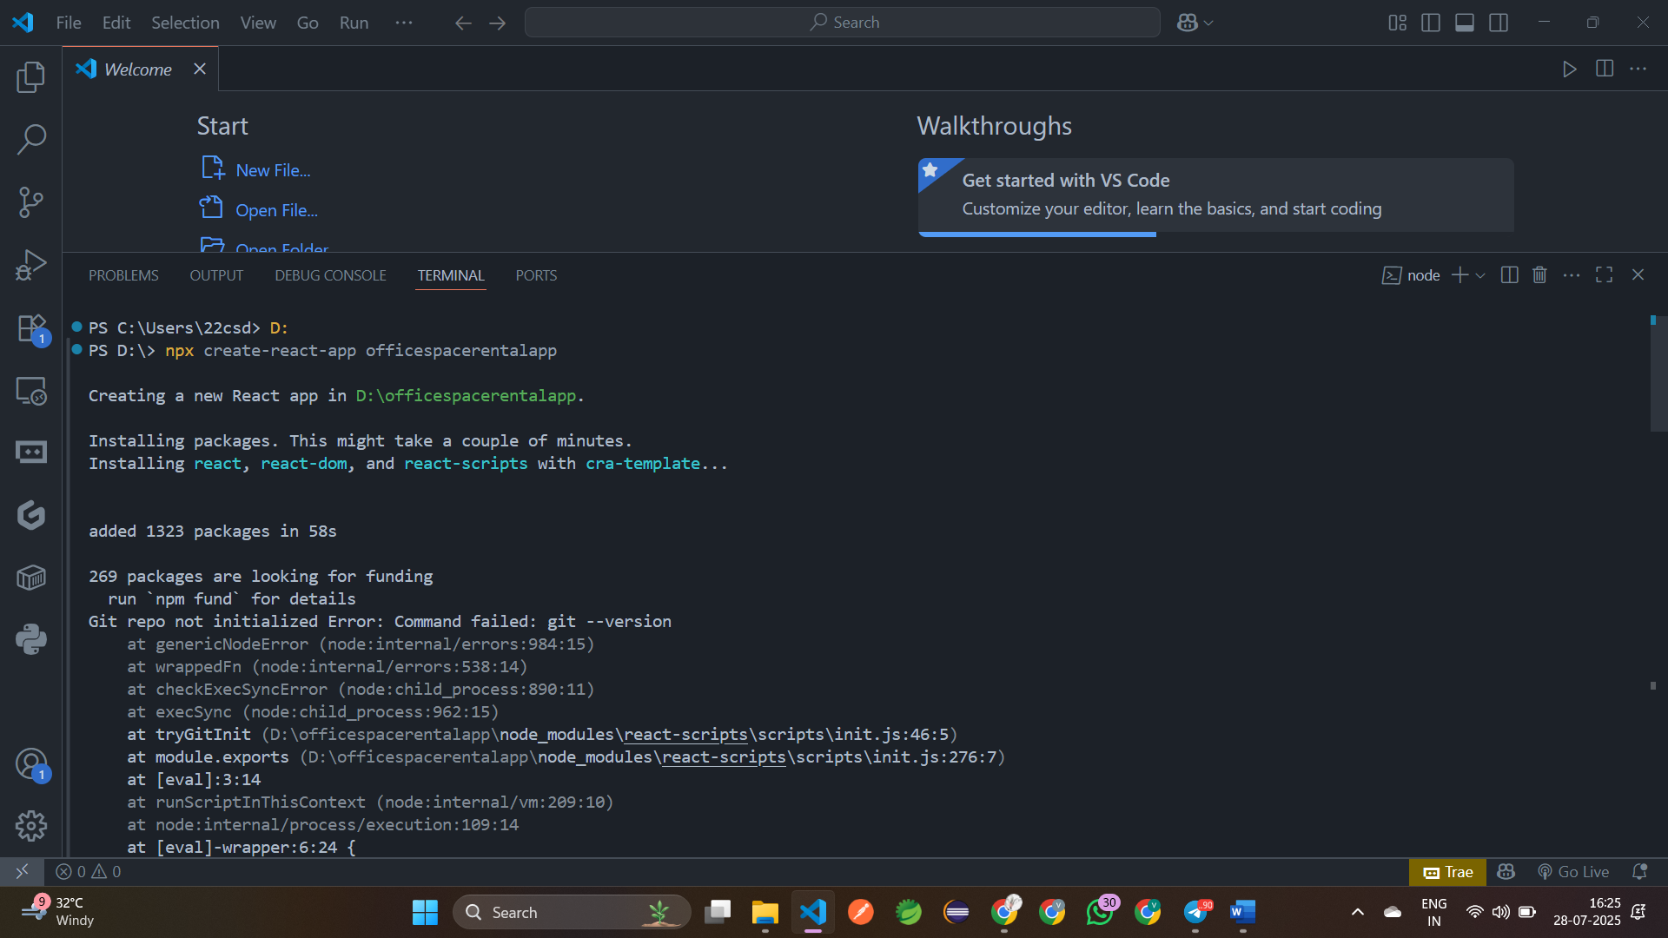

Step 4: Create a component **OfficeSpace.js**

import React from "react";  
 import './OfficeSpace.css';  
 function OfficeSpace({ item }) {  
 let rentColor = item.Rent <= 60000 ? 'textRed' : 'textGreen';  
   return (  
     <div className="box">  
     <h2>{item.Type}, at Affordable Range</h2>  
     <img src={item.Image} width="25%" height="25%" alt="Office Space" />    
     <h3>Name: {item.Name}</h3>  
     <h3 className={rentColor}>Rent: Rs. {item.Rent}</h3>  
     <h3>Address: {item.Address}</h3>  
     </div>  );  
 }export default OfficeSpace;

Step 6: Create another component **OfficeSpace.css:**

.box {  
   width: 300px;  
   display: inline-block;  
   margin: 10px;  
   padding: 10px 20px;  
   vertical-align: top;  
   text-align: center;  
 }  
 .textRed {  
   color: red;  
 }  
 .textGreen {  
   color: green;  
 }

step 7: Open **src/App.js** and modify it

import './App.css';  
import OfficeSpace from "./OfficeSpace";  
 function App() {  
  const officeList = [  
 { Type: "Office Space",  
 Image: "https://thumbs.dreamstime.com/b/office-work-place-5879959.jpg",  
 Name: "DBS",  Rent: 50000,   Address: "Chennai"    },  
 { Type: "Office Space",Image: https://t4.ftcdn.net/jpg/03/84/55/29/360_F_384552930_zPoe9zgmCF7qgt8fqSedcyJ6C6Ye3dFs.jpg",      Name: "Regus",      Rent: 70000,      Address: "Bangalore"    }];  
 return (  
       <div style={{ textAlign: 'center' }}>  
         {officeList.map((item, index) => (  
           <OfficeSpace key={index} item={item} />        ))}  
       </div>  );  
 } export default App;

step 8: Run the App using **npm start**

Url: <http://localhost:3000>

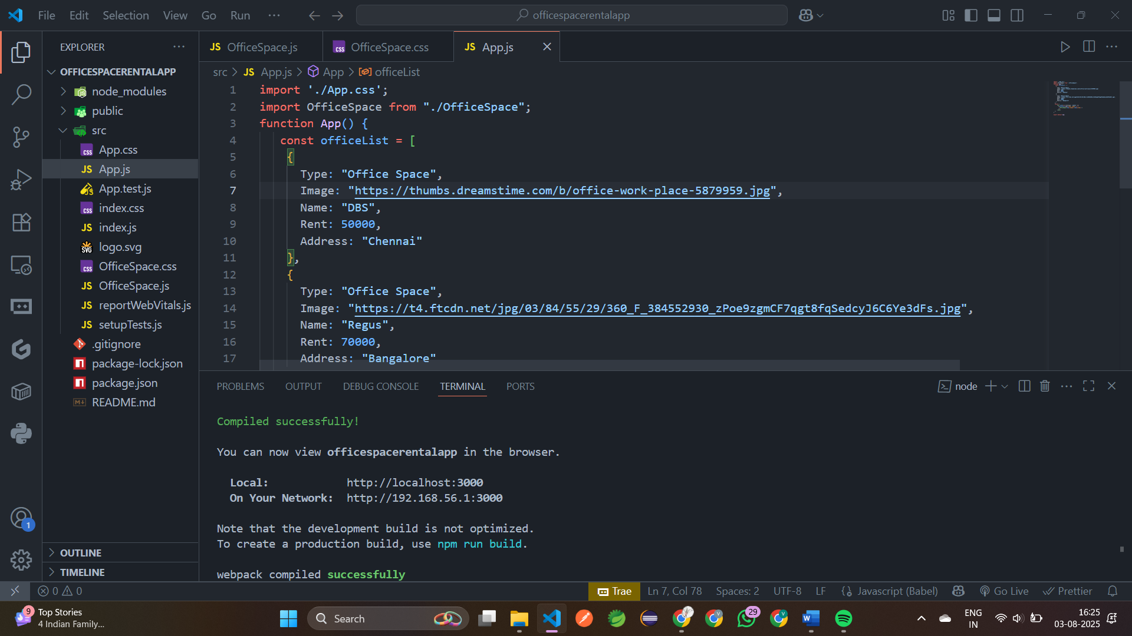

**Output:**

